Linux Set-Up Notes – Extended for Etrading Projects
- Logon to the Tokyo Linux Dev Server
See Appendix A below for complete instructions

- Create Your Workspace
Navigate to your workspace directory or create one as follows using the mkdir command
/home2/micfs/[userid]/work/[YYYYMMDD]

Workspace Example
/home2/micfs/burgesni/work/20181008

- Checkout Source Code
Using SVN checkout the source code to your workspace. Navigate to your workspace and checkout using the SVN command svn co + repository address
SVN Checkout Command
svn co http://tkcvsapd1/repos/M-Library/trunk/global/trunk_common

- Set Compiler Environment Variables
This step only needs to be completed only once when preparing your first workspace. This is done via bash script. Firstly copy the bash script to your home folder then secondly run the bash script.
Copy Bash Script from Ian’s workspace to your Home Folder
cp ~castleia/hirayama.bash_profile ~/.

- Run Bash Script
source ~/hirayama.bash_profile

- Build The Source Code
Navigate to your workspace trunk_common/src folder and call the appropriate makefile as follows.
Navigate to your Workspace MakeFiles, which are under trunk_common/src
cd /home2/micfs/[userid]//work/[YYYYMMDD]/trunk_common/src
There are 2 make files; Makefile is to build only the core projects, whereas Makefile.everything is used to build core projects and etrading projects. Build the source code using the following makefile command, please note the command is case sensitive, not the M in make file is capitalized.
Build Everything
make –f Makefile.everything –j 10
This means use make on file (-f) Makefile.everything using (-j) 10 jobs or cores

- Running Google Tests & TestNinja in Linux
Firstly copy TestNinja.py from the resources folder to your workspace lib folder

Navigate to the lib folder in your workspace
cd [workspace path]/trunk_common/src/lib

Copy TestNinja from your Workspace Resource folder to the /lib folder
cp /home2/micfs/[userid]//work/[YYYYMMDD]/trunk_common/resource/utilities/Apps/TestNinjaPython/* .

Convert the TestNinja.py File to an Executable
chmod +x TestNinja.py
After converting the TestNinja.py to an executable it should turn green when viewing the list of files using the ls command.

- Set the MLIB Variable as Required by TestNinja

Navigate to trunk_common
cd /home2/micfs/[userid]//work/[YYYYMMDD]/trunk_common

The present working directory using the command “pwd” this path can be copied into the export command below.

Set the MLIB Environment Variable
export MLIB =”Path to trunk_common”

Example
export MLIB=/home2/micfs/[userid]//work/[YYYYMMDD]/trunk_common

- Run Google Test using Test Ninja

Navigate to the lib folder in your workspace
cd /home2/micfs/[userid]//work/[YYYYMMDD]/trunk_common/src/lib

Run TestNinja
./TestNinja.py

To terminate the test process early use CTRL+C

For a full list of TestNinja and Google Test Switches and further help type
./TestNinja.py --help
./GOOGLE_TEST.exe --help

Appendix A: PuTTy Settings
- Enter Server IP Address and Select SSH
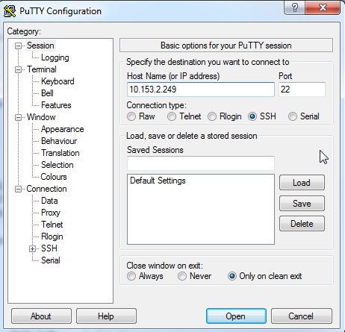
- Add Your Login ID
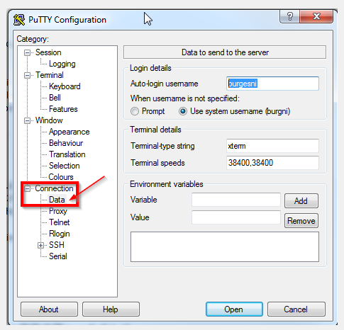
- Set the Command Interpreter to use bash (default is often cshell)
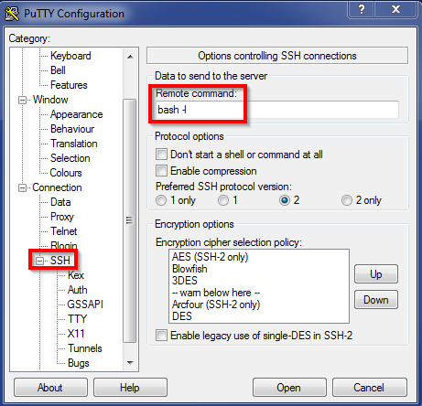
- Save the Connection Settings for Future then Select Open
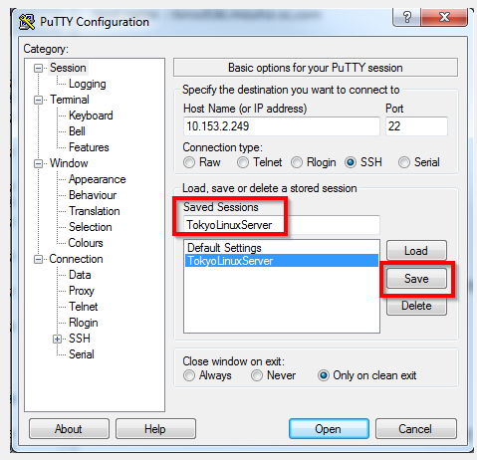

- Select Yes to Trust and Connect
